Wireframe Documentation

# News Article Sorting

|  |  |
| --- | --- |
| Written By | Rajat Chaudhari |
| Document Version | 1.0 |
| Last Revision Date | 14/04/2022 |

# Home Page

## 1. Before Submitting Input

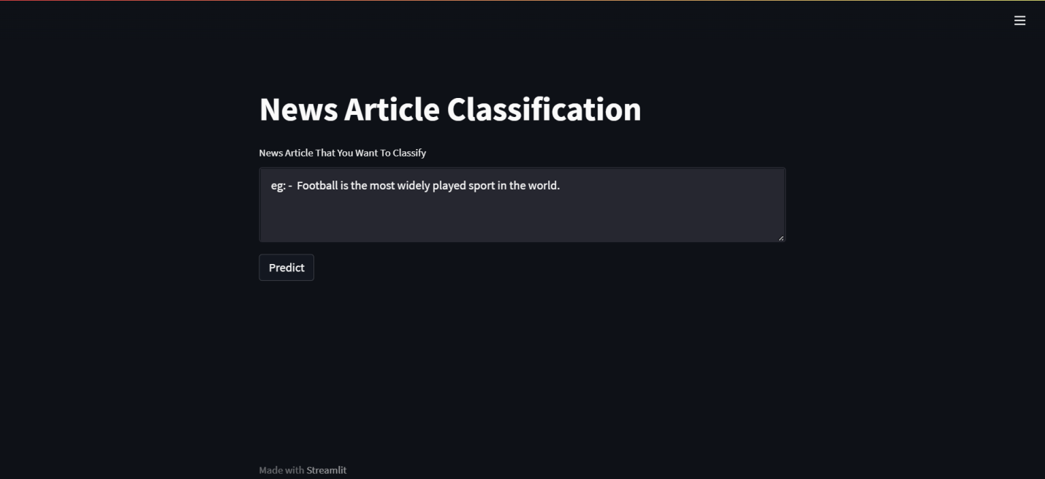

**2. After Submitting Input**

